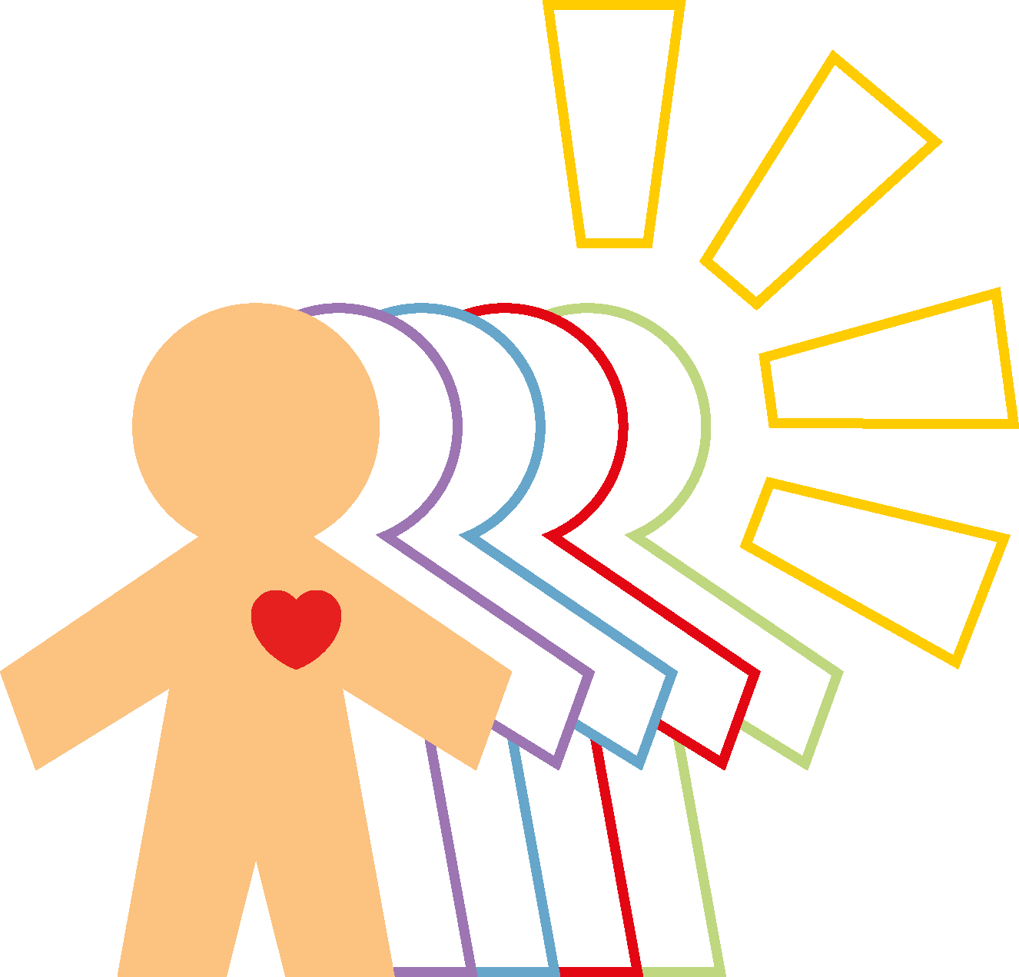
BEYOND CHEMICAL BALANCE

Name: ________________________________________________________

Date: ________________________________________

Speed of healing is determined by Chemical balance in the body. Chemical balance is determined, in large, by what you eat. Please indicate the amounts and frequency that you partake in the following … BE HONEST!

 | PER DAY | PER WEEK
- Coffee (caff/decaff) | _____________cups | _____________cups
- Tea (regular/herbal) | _____________cups | _____________cups
- Sugar, sweets, dessert etc. | _____________times | _____________times
- Salt, salty snacks, crisps etc. | _____________times | _____________times
- Do you add salt to your food? | YES _________NO_________ | SOMETIMES __________
- Red meat (beef, pork, bacon etc) | _____________times | _____________times
- Chicken / Fish | _____________times | _____________times
- Milk | _____________cups | _____________cups
- Other dairy (cheese, ice cream etc) | _____________times | _____________times
- Fresh fruits | _____________times | _____________times
- Fresh vegetables (non canned) | _____________times | _____________times
- Pasta/breads (white flour) | _____________times | _____________times
- Whole grain foods | _____________times | _____________times
- Artificially sweetened products | _____________times | _____________times
- Fast food | _____________times | _____________times
- Fats (nuts, avocado, coconut, oils etc) | _____________times | _____________times
- Processed foods (cereals, boxed/ frozen meals) | _____________times | _____________times
- Alcoholic beverages | _____________cups | _____________cups
- Soft drinks (regular/caffeine free) | _____________cups | _____________cups
- Diet sodas | _____________cups | _____________cups
- Cigarettes/cigars etc | _____________packs | _____________packs
- Water | _____________cups | _____________cups

Cravings (circle all that apply) SALT SUGAR CHOCOLATE BITTER CARBS/STARCHES ICE

What is a typical breakfast for you?

What is a typical lunch for you?

What is a typical evening meal for you?

List any vitamins/minerals you are currently taking______________________________________________________

Major life changes (divorce / loss / trauma etc) ___________________________________________________________

